Edition and typological analysis of an oral corpus of “genaillard” (northern Dauphinois) Francoprovençal: an input to the internal classification of a severely endangered language
Antoine HEINTZMANN, Structures Formelles du Langage (CNRS-Paris VIII)

The aim of this paper is to draw the profile of a dialect of a narrow area, the Velin region, located in the dead center of the Francoprovençal/Arpitan linguistic area, and acting as an internal buffer zone between three of the major dialects of Francoprovençal: Lyonnais, Dauphinois and Bressan. This analysis will focus mainly on phonological features and acoustic analysis while not leaving behind some major morphosyntactic idiosyncrasies.
Presentation and context. The Velin area, also known as Plaine de Lyon or (more commonly as Est Lyonnais) is a historical region located east of the city of Lyon, astride the two administrative prefectures of Rhône and Isère. It is geographically delimited by three rivers: the Rhône river to the north and east, the Ozon river to the south, and finally, the Bourbre river to the west. Historically, all of the area was included within the historical Dauphiné province (which later became the Isère prefecture), before the Western half of it was gradually made to belong to the Rhône prefecture, it has thus historically undergone significant political and cultural influence from both Lyon and Grenoble as directional centers (see figure; Charvet, 1984). The region is thus located right in the middle of the Francoprovençal language area, more precisely straddled between the Lyonnais and Dauphinois dialects, and closely bordering the Bressan dialect area to the north. Unlike Eastern dialects such as Valaisan and Valdôtain, which generally benefit from a better conservation by the local population, and as a consequence, a more thorough documentation by both linguists and pedagogues, dialects located on the Western half, like Lyonnais, Dauphinois or Bressan, tend to undergo a much harsher erosion, and suffer from critically low awareness. This is happening among the scientific community or the general population, with the only conservation efforts being pushed by a nebulous set of rather uncoordinated local circles (Chocquet, 2011).
Data. In July 2019, among those scarce conservation and documentation efforts, the municipality of Genas, located in the dead center of the Velin region, launched a local heritage awareness campaign entitled “Les Genadines”, consisting of guided visit paths of historical interest within the town. On that occasion, audioguides were produced for each site (31 texts in total), each of them being recorded in both French and the local “genaillard” dialect of Francoprovencal. The latter part was read by Pierre Mingeat, a local language revitalization activist, which happens to be one of the last few remaining native speakers of genaillard. All texts were initially written in French and then translated in Francoprovencal by Mr Mingeat himself. This set of recordings was further completed in May 2021 by five new bilangual audio texts intended for the newly created museal space of Gandil, dedicated to the rural and agricultural history of the region. Overall, even though certain limitations of the methodology must be kept in mind when analyzing these recordings such as the inability for this kind of experiment to access more colloquial expressions, or the usual biases associated with translation (calques, failure to transpose some semantic framings in the target language, etc.), this corpus remains a useful dataset for a language that tremendously lacks prior documentations. The only other data for this zone are linguistic atlases, with the dialects of surrendering towns (such as Pusignan or Toussieu; see figure) being partially documented, this dataset being one of the only available set of recordings available.
Results. The dialect of Francoprovençal spoken in Genas, like many other topolects attested in the Velin, fits relatively well within the (northern) Dauphinois dialect area, given that many of its features being shared all over the Northern Dauphinois region (Stich, 2016):
- A major feature of the northern Dauphinois region is the realization of the palatalized velar plosives /k/ and /g/ from Latin (when followed by /a/) as dental fricatives /θ/ and /ð/ (instead of French /ʃ/ and /ʒ/, <ch> and <g> in ORB orthographical form) → CABALLUS > [θyvɑw] ‘horse’; GAUDIOSUS > [ðojyː] ‘happy, jolly’
- The monophtongation of word-final /je/ (<-iér> in ORB) in /i/, especially in palatalized infinitive verbs and names descending from Latin -ARIUS → PRIMARIUS > [prymi] ‘first’; *HARNISCARE > [arnaθi] ‘to harness’
- The coalescence of fricative + palatal glide sequences such as /sj/ and /zj/ in /ʃ/ and /ʒ/, especially in nouns ending with -TIŌ or -SIŌ in Latin → ACTIŌ > [akʃɔ̃] “action”; in those cases, the palatal coalescence can trigger, at least in genaillard, a regressive palatalization harmony on preceding fricatives → CONCERTATIŌ > [kɔ̃ʃərtpʃɔ̃] ‘concertation’; RE-TRANSMISSIŌ > [rətrɑ̃ʃmiʃɔ̃]
Ableit, being a transition dialect, “Velinese” varieties display features that can rather be associated with Lyonnais, such as:
- The word-final unstressed feminine vowel /i/ (that has palatalized from Latin /a/ when preceded by coronals containing a palatal element issued from diachronic palatalization), where other dialects have reduced this vowel to a schwa → DIRECTA > [ˈdrati] ‘right’; FABRICA > [forði] ‘forge’
- The labialization of word final stressed /e/ (ORB <èt>) in /œ/ in Latin names ending in -ITTUS or -ECTUS → IULITTUS > [ðɥijœ] ‘July’; OBIECTUS > [obðœ] ‘object’
- The opening of stressed Latin Ē and Ĭ (merged into proto-Romance */e/) in /ɑ/ or even /a/ unlike in other dialects, where it was mostly conserved as /ɛ/ (<ê> in ORB) → TRĒS > [trɑ] ‘three’; VITRUM > [vɑː] ‘glass’
Conclusion. The “Velinese” dialect, showcased in these recordings, acts self-evidently as a transition dialect between Lyonnais and Dauphinois (with much less influence from Bressan), thus reflecting the external history of the area being shunted back and forth between Lyon and Grenoble, the two main cultural nerve centers of the region.
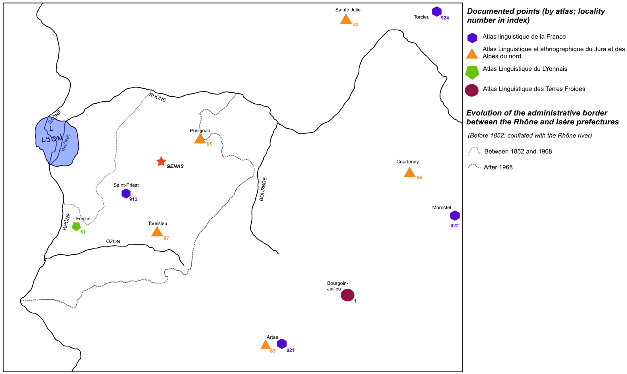
Bibliography
Charvet, A. (1984). De Lyon à Satolas : Le pays du Velin. Des origines à nos jours. AREM-communication
Chocquet, M. (2011). Langue et identités transfrontalières : La pratique du francoprovençal dans le « “Far-West” » français [Master's thesis]. Université Pierre Mendès-France.
Stich, D. (2016). Parlons francoprovençal. Une langue méconnue. L’Harmattan

All recordings are available for both languages in open access at: https://genas.fr/ma-ville/decouvrir-genas/patrimoine-genassien/les-genadines/

